REPUBLIC OF

THE GAMBIA



MINISTRY OF FINANCE & ECONOMIC AFFAIRS

THE QUADRANGLE, BANJUL, THE GAMBIA.

Tel;+220 4225713 / Fax: +220 4227954, email: [info@mofea.gov.gm](mailto:info@mofea.gov.gm)

**REPUBLIC OF THE GAMBIA  
GAFSP PROJECT PROPOSAL**

Declaration by the Government of The Gambia:

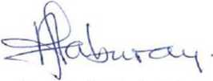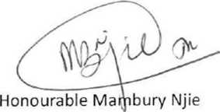The present Project Proposal Document for GAFSP Funding has been approved by the Government of the Gambia and endorsed by the Ministry of Finance and the Ministry of Agriculture in the Gambia.

**Minister of Finance**

Government of The Gambia

Honourable Amie Fabureh

**Minister of Agriculture**

Government of The Gambia

Datt! '7

